Create a git repository in local
- Open the GIT Bash and move to the local folder
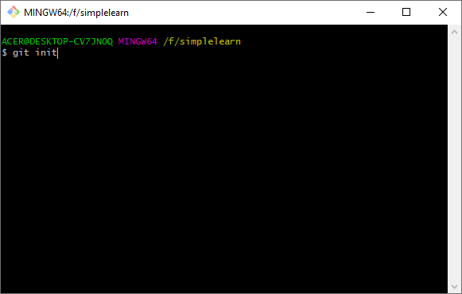
- Configure the github to the local folder
git remote add origin https://github.com/chockkalingamk/Simplilearn.git
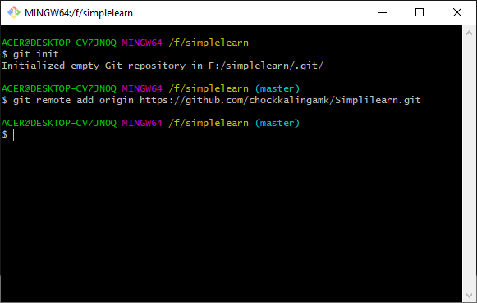

- Pull the source code folder from the GIT hub to local
git pull origin master
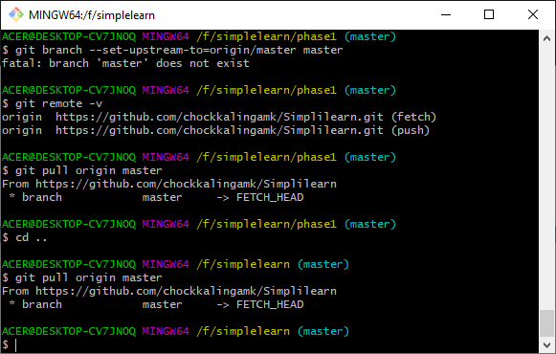
Import the source code of phase2/angularquizapplication into the visual studio code

- Open a new angularquizapplication project
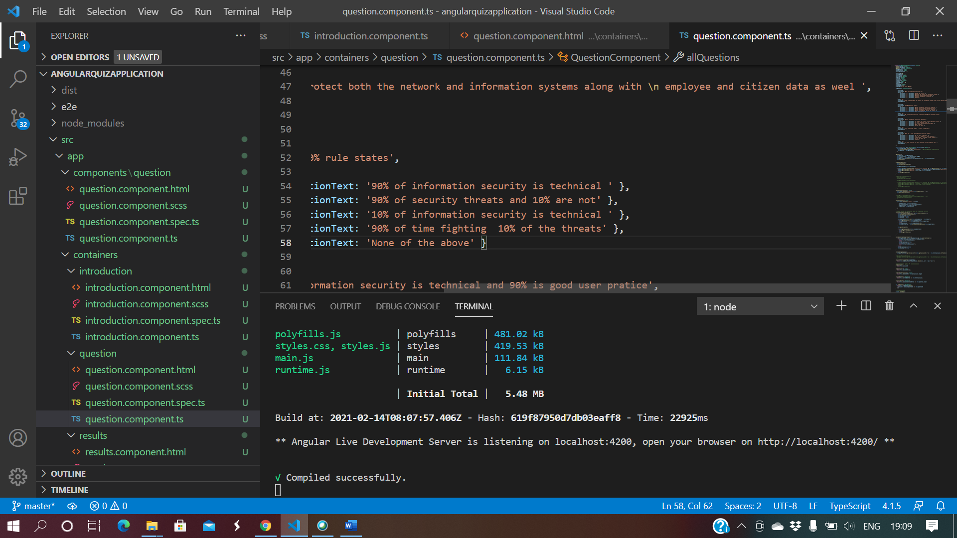

- Follow the below steps to Install few things
- npm install --save @angular/material @angular/cdk
- npm install bootstrap
- npm install --save @ng-bootstrap/ng-bootstrap
- npm install ngx-bootstrap --save
- ng add @angular/material
- ng add @angular/localize
- npm i angular-progress-bar

- Start the server by ng serve as follows
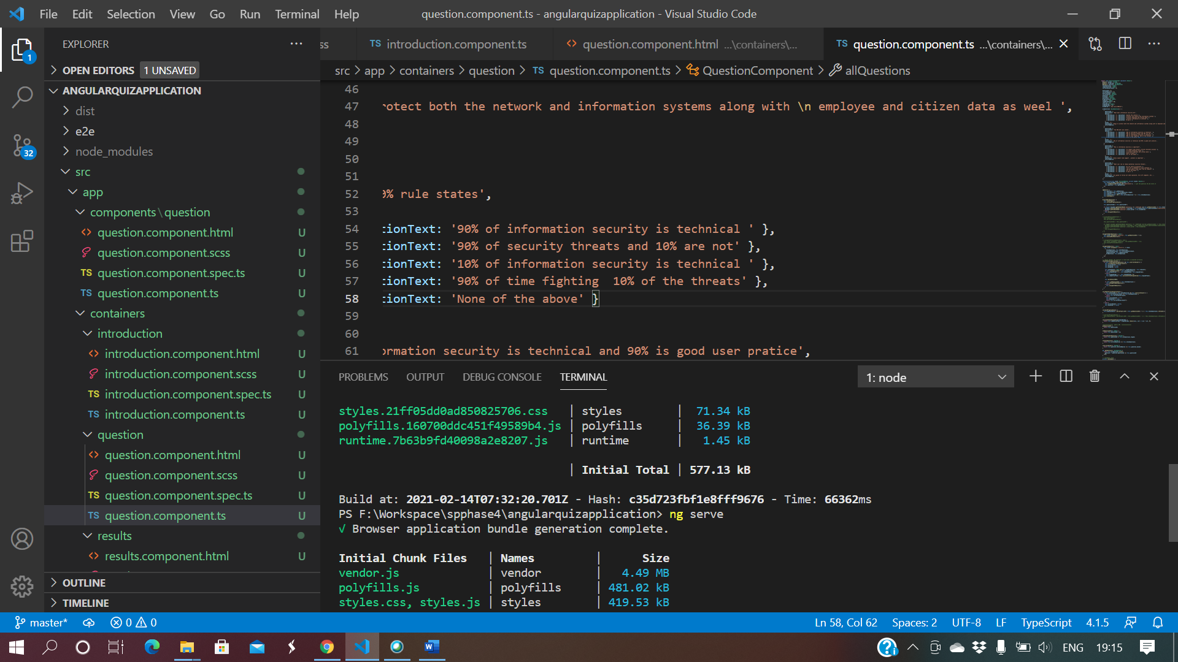
- Provide the URL http://localhost:4200/ to proceed with the application

